CS 305 Module Five Coding Assignment Checksum Verification Template

Instructions
Using the instructions from the Module Five Coding Assignment Checksum Verification Guidelines and Rubric, replace the bracketed text with the relevant information in your own words.

Algorithm Cipher
A: SHA-256 has been chosen as the recommended cipher due to it being a checksum verification system that avoids collisions. SHA-256 is a cryptographic hash function that is a fixed 256-bit hash value for any input and generates immune to collision data checksums to ensure file integrity.

Justification
A: The justification for choosing SHA-256 was due to its strong collision resistance. It ensures that that two inputs don’t generate identical hash fingerprints. Higher bit size versions like SHA-384 or SHA-512 might be too much for non-critical systems and will use more resources, causing slower performance.

Generate Checksum

You’ll submit your refactored code to your instructor. Your instructor will review it and this document.
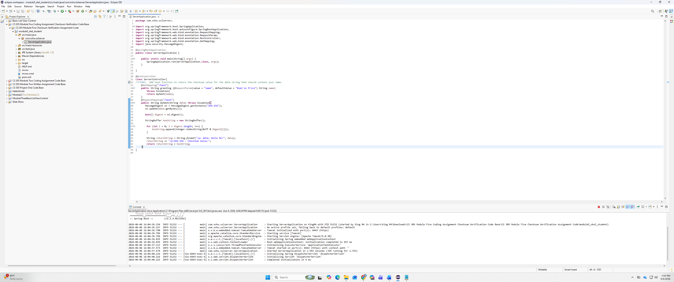

Verification

